**SIMIYU JOY ABIGAEL - WT/21/120**

**EMAIL: joy.simiyu@womentechsters.org**

**Practical Activity 2**: Assume that you are working as Azure cloud Information Security Officer in maintaining client’s data and servers running.

1. Deploy a windows server 2016 Gen 1 remotely on your machine from Azure cloud.

This involves creating a windows server virtual machine from azure cloud by logging in, navigating to the search bar, searching for ‘virtual machines’, clicking ‘add’ after which you fill the details required in the project details and create it.

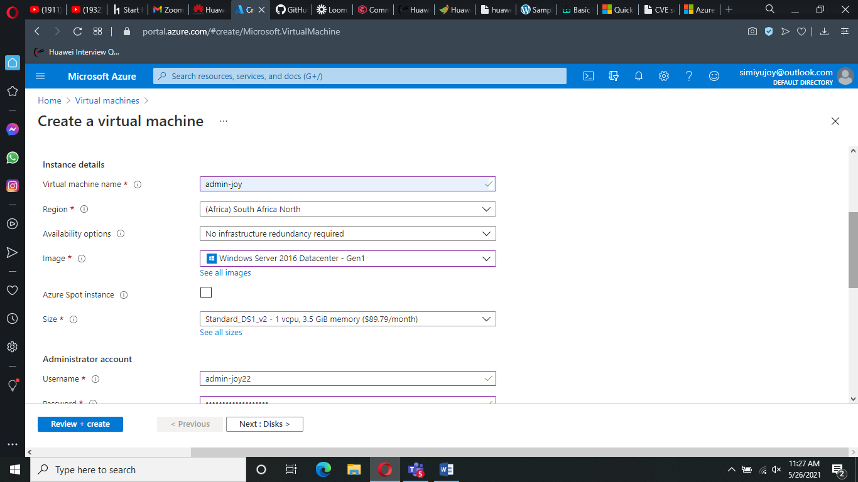

*Process of creating the virtual machine called VMPractical*

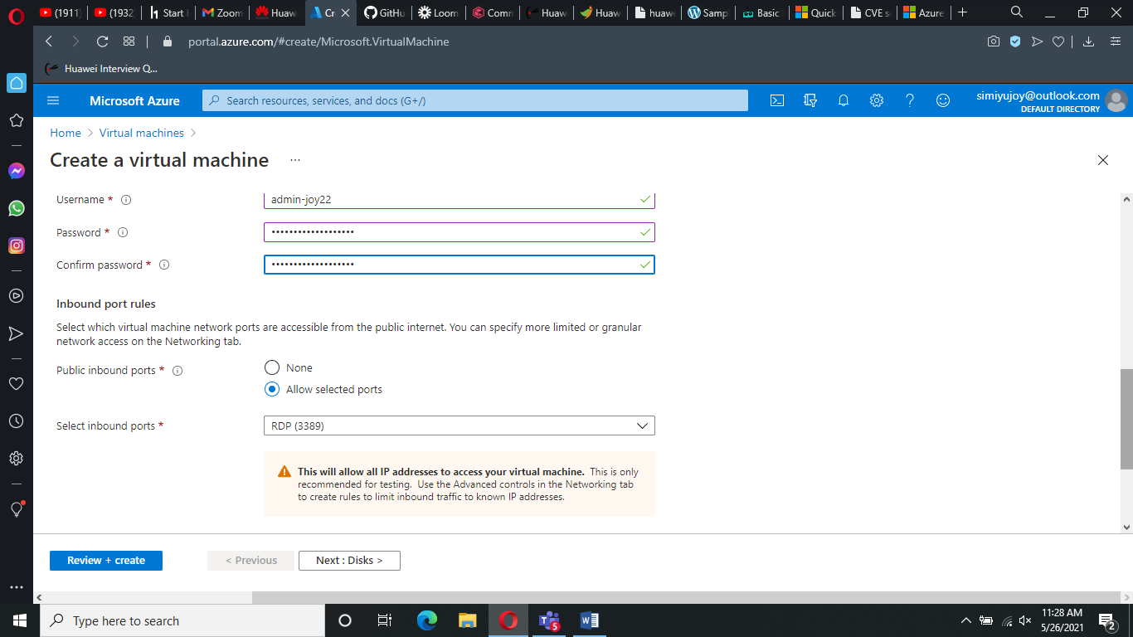

*Process of creating the virtual machine2*

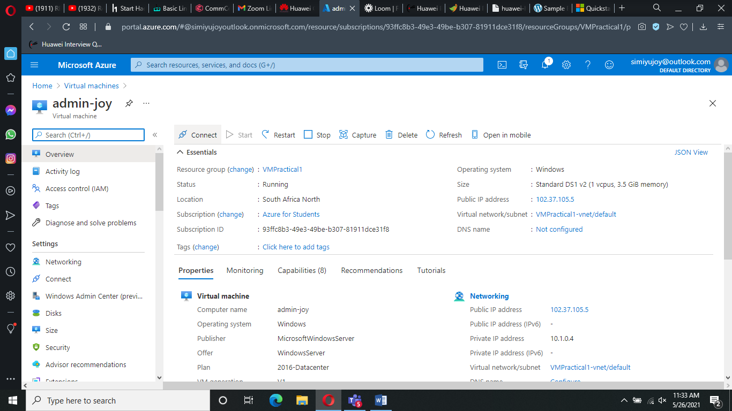

1. Install the Windows Feature – Web Server Management tools and confirm from your browser.

This involves launching the cmdlet on the virtual machine created and inputting the code:

**Install-WindowsFeature -Name Web-Server -IncludeAllSubFeature -ComputerName Server1 –WhatIf**

This code installs the windows feature – web server management tools when run. This installation is proved on the browser as shown below.

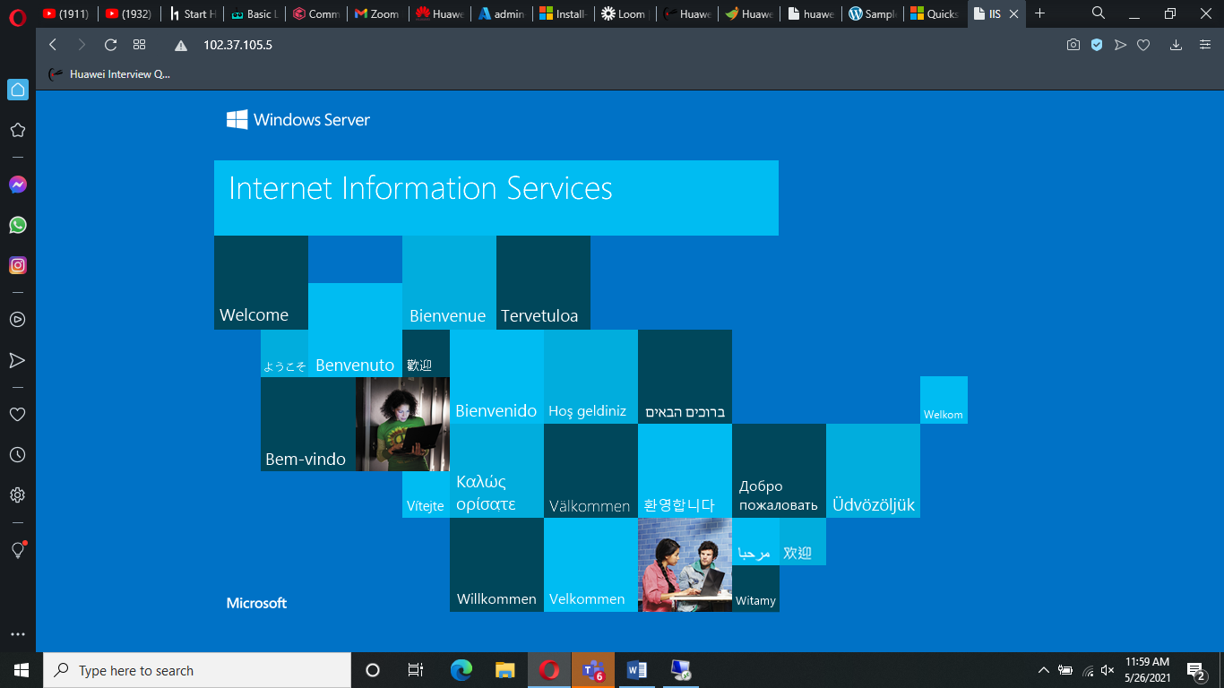

1. Create a Site Recovery Service Vault. Since your site will contain only one Windows Server just add the Windows server to Replicated Items in the Recovery Service Vault to be tracked.

This is a management entity that stores recovery points of data created over time and provides an interface to perform backup related operations. It is created as shown below:

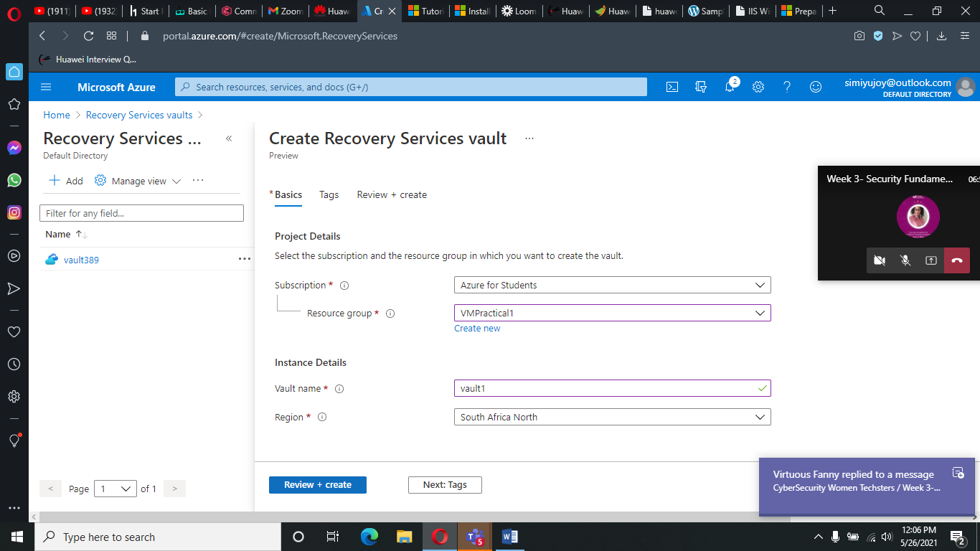

This is then followed by enabling a replication which works by processing the data in the cache which contains data that is written and transferred from the storage disks, and sending it to the target storage account, or to the replica managed disks. The enables replication is shown below:

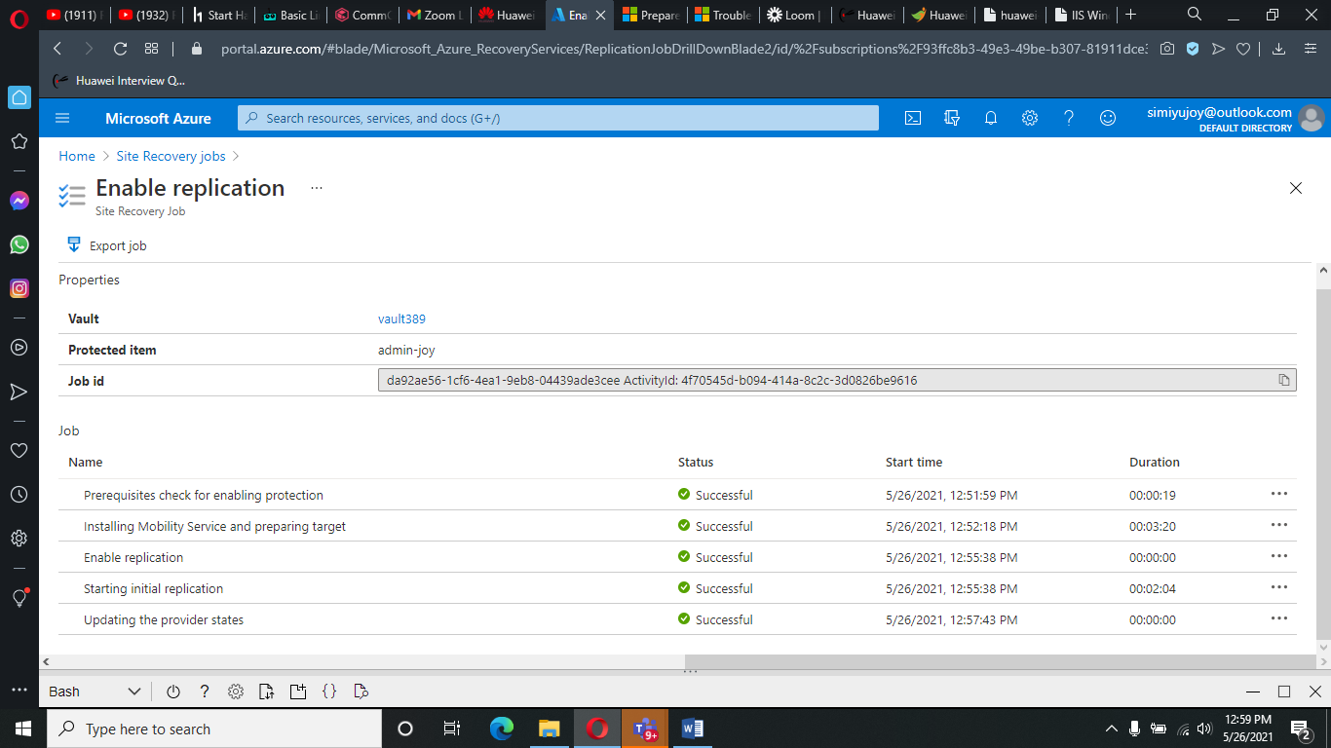

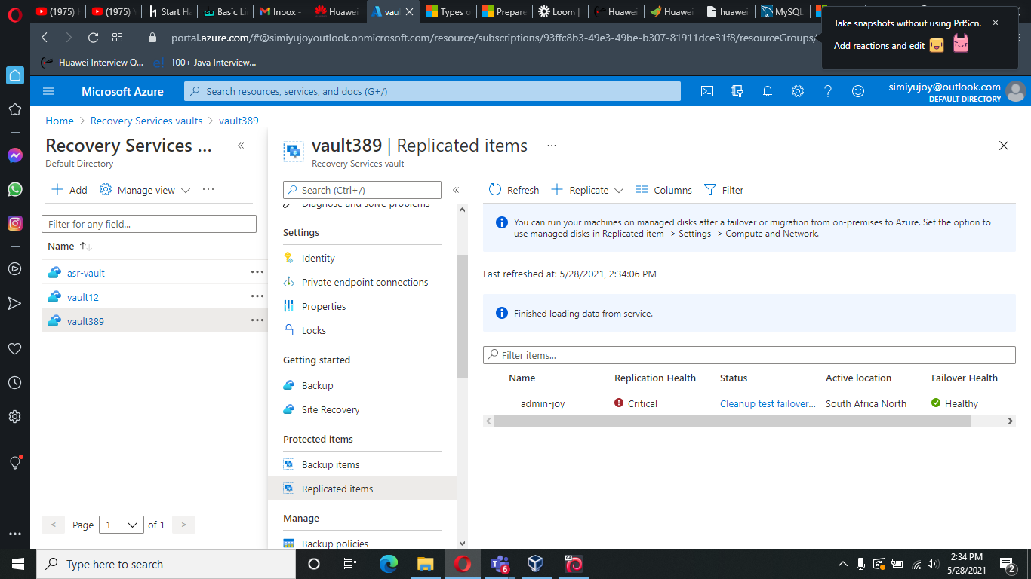

1. Stop the Windows server from Azure to Assume it’s ‘breakdown’

This process involves changing the virtual machine’s status from running to stopped.

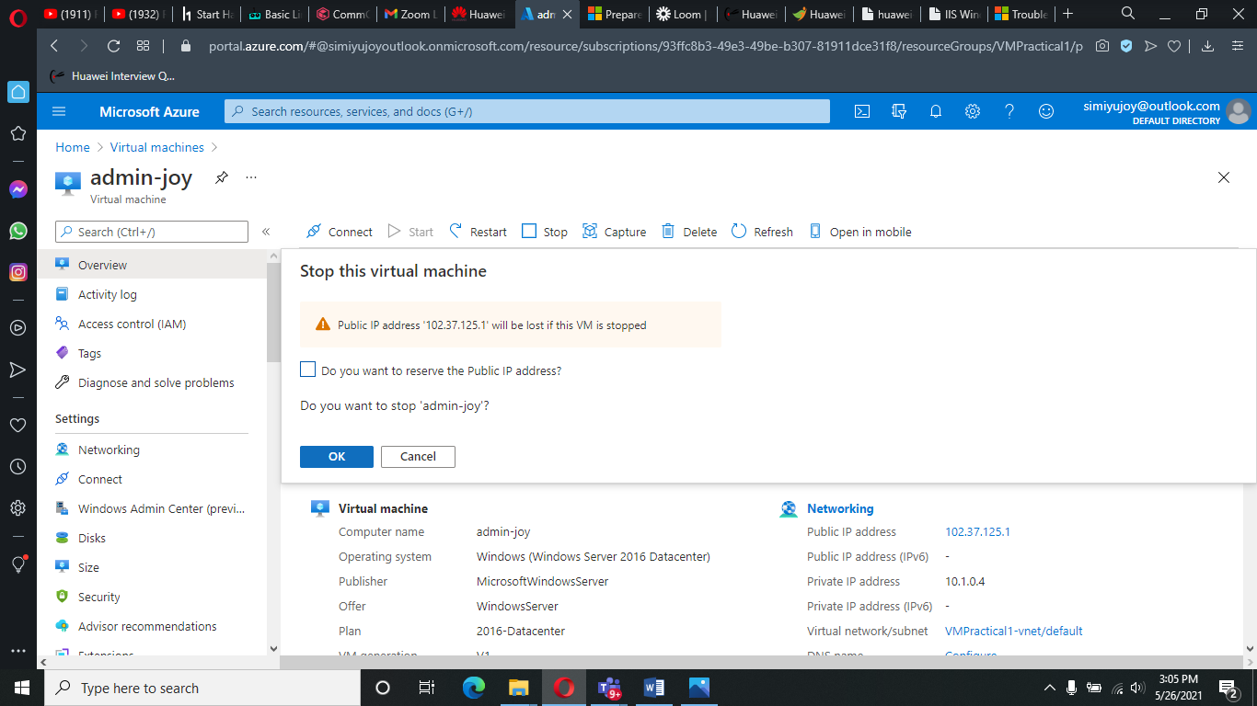

1. Then perform a Test Failover for the windows server.

This process involves validating a system's ability to be able to allocate extra resource and to move operations to back-up systems during the server failure due to one or the other reasons.

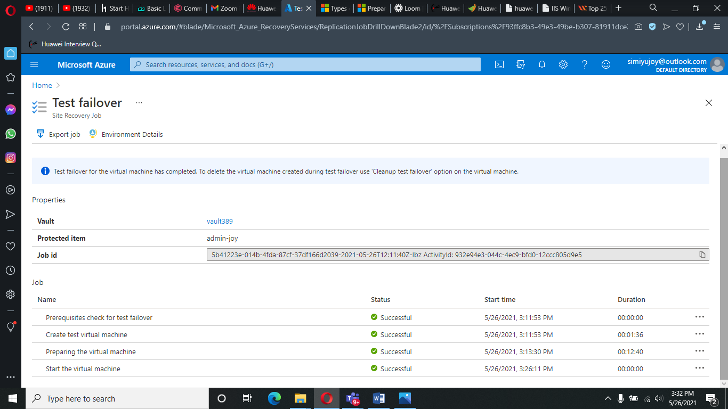

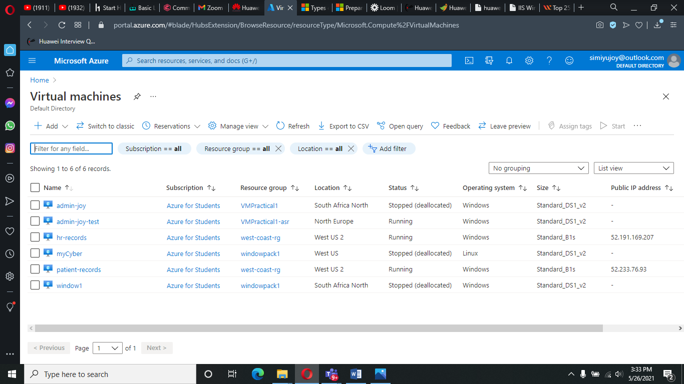

*Replicated copy of the windows server.*